**TCP IN ACTION: SLOW START, CONGESTION AVOIDANCE, AND FAST RETRANSMIT**

Consider the figure below, which plots the evolution of TCP's congestion window at the beginning of each time unit (where the unit of time is equal to the RTT); see Figure in the text. In the abstract model for this problem, TCP sends a "flight" of packets of size *cwnd* at the beginning of each time unit. The result of sending that flight of packets is that either *(i)* all packets are ACKed at the end of the time unit, *(ii)* there is a timeout for the first packet, or *(iii)* there is a triple duplicate ACK for the first packet. In this problem, you are asked to reconstruct the sequence of events (ACKs, losses) that resulted in the evolution of TCP's *cwnd* shown below.

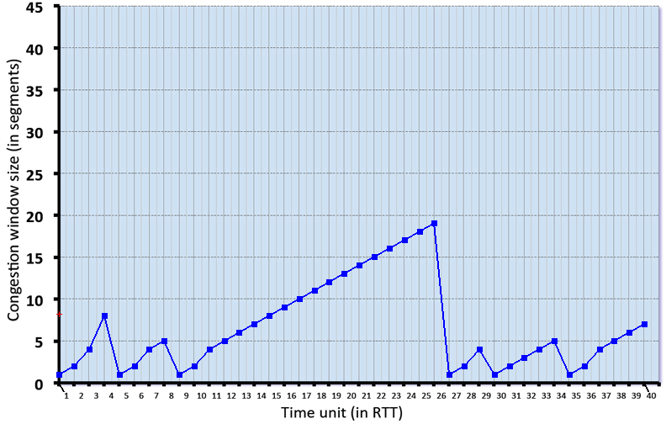

Consider the evolution of TCP's congestion window in the example above and answer the following questions. The initial value of cwnd is 1 and the initial value of ssthresh (shown as a red +) is 8.

**QUESTION LIST**

1. Give the times at which TCP is in slow start. Format your answer like: 1,3,5,9 (If none submit blank)  
  
2. Give the times at which TCP is in congestion avoidance. Format your answer like: 1,3,5,9 (If none submit blank)  
  
3. Give the times at which TCP is in fast recovery. Format your answer like: 1,3,5,9 (If none submit blank)  
  
4. Give the times at which packets are lost via timeout. Format your answer like: 1,3,5,9 (If none submit blank)  
  
5. Give the times at which packets are lost via *triple ACK*. Format your answer like: 1,3,5,9 (If none submit blank)  
  
6. Give the times at which the value of *ssthresh* changes (if it changes between t=3 and t=4, use t=4 in your answer)

**SOLUTION**

1. The times where TCP is in slow start are: 1,2,3,5,6,9,10,27,28,29,30,35,36

2. The times where TCP is in congestion avoidance are: 4,7,8,11,12,13,14,15,16,17,18,19,20,21,22,23,24,25,26,31,32,33,34,37,38,39,40

3. The times where TCP is in fast recovery are:

4. The times where TCP has a loss by timeout are: 4,8,26,29,34

5. The times where TCP has a loss by triple duplicate ACK are:

6. The times where the *ssthresh* changes are: 5,9,27,30,35

